Plan of Action – RDS Database Isolation for EO & IS Applications

Current Setup:
One MySQL RDS instance (single endpoint) → being shared by all services of EO and ISOCS.
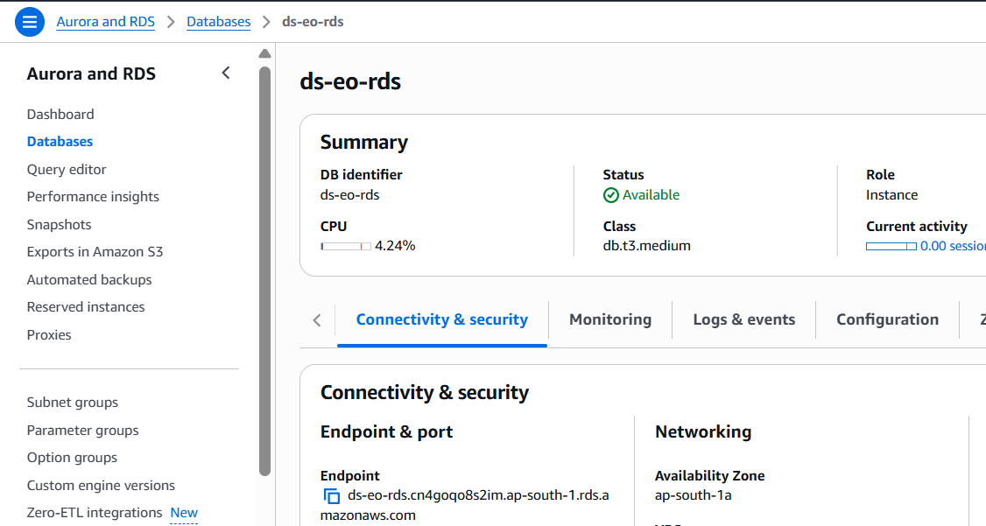
Inside that RDS:
Each microservice has its own database/schema (cart_service_dev, Coupon_Service_dev, is_ gs_antenna_settings_dev, etc.).
The Parameter Store env files hold DB connection details (host, port, username, password, database).
Example:
agent_data_processing
central_gs_antenna_settings_dev
cart_service_dev
Coupon_Service_dev
So in short:
1 RDS → many schemas → used by ~15+ services per app (EO & IS) across dev/uat/prod.

Proposed Architecture
We will segregate RDS instances per application and environment:
IS
Dev/UAT → New db.t3.small (single-AZ) RDS MySQL instance
Prod → New db.t3.small (Multi-AZ HA) RDS MySQL instance
EO
Dev/UAT → New db.t3.small (single-AZ) RDS MySQL instance
Prod → New db.t3.small (Multi-AZ HA) RDS MySQL instance
This ensures environment and application isolation while maintaining cost efficiency.
That means after migration we’ll have:
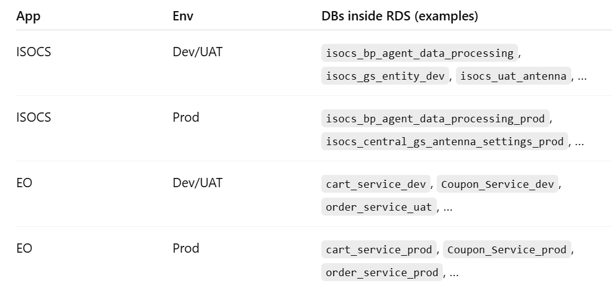

Pre-migration checklist
1.Inventory databases (schemas) per app & env:
# login to current MySQL RDS
mysql -h <old-rds-endpoint> -P 33306 -u admin -p -e "SHOW DATABASES\G"
Save the list to a file and group by is_* and eo_* and by suffix _dev/_uat/_prod patterns.
2. Decide migration order (IS first — dev/uat -> prod -> EO dev/uat -> EO prod).
3. Backup: take a snapshot of the current RDS before operations

Migration Plan
Step 1: Snapshot Creation
Take a manual snapshot of the existing RDS instance as soon as the downtime starts.
This snapshot will contain all databases (EO + ISOCS + Dev/UAT/Prod).
Step 2: Restore Snapshot into New Instances
Restore the snapshot four times to create:
- ISOCS Dev/UAT RDS
- ISOCS Prod RDS (Multi-AZ enabled)
- EO Dev/UAT RDS
- EO Prod RDS (Multi-AZ enabled)
Step 3: Database Cleanup
For each new RDS instance:
ISOCS RDS → Drop EO-related databases.
EO RDS → Drop ISOCS-related databases.
Example cleanup command:
DROP DATABASE cart_service_dev;
DROP DATABASE coupon_service_dev;
Step 4: Application Reconfiguration
Update AWS Parameter Store with the new DB_HOST values per service.
Redeploy backend services via Jenkins pipelines, so containers connect to the new RDS endpoints.
Step 5: Validation
Dev/UAT environments validated by respective developer teams.
Production cutover scheduled with planned downtime, followed by post-migration validation.

Rollback Strategy:
- Keep current RDS running during migration.
- If validation fails, switch DB_HOST in Parameter Store back to old RDS and redeploy.
- No destructive action until all applications are validated.

